**///** /Business Workshop OSLO – TRAPEZE (Core consent)/

**////////////////////////////////////////////////////////////////////////////////////////////////////////**

**Date**: 19/08/2021

**Time:** 13:00

**Location**: Online – Microsoft Teams Meeting

# Attendees

* Digitaal Vlaanderen
  + Frédéric Hennequin
  + David Van den Brande
  + Lauro Vanderborght
  + Laurens Vercauteren
  + Kevin Haleydt
  + Michael Geamanu
* Datanutsbedrijf
  + Dorien Bauwens
  + Filip Borloo
* Inrupt
  + Esther De Loof
  + Nick Mondada
* Cronos Group:
  + Christophe Cop

# Agenda of the working group

|  |  |
| --- | --- |
| **Part 1** | Welcome |
| **Part 2** | Background & Context |
| **Part 3** | Open Standards for Linked Organisations (OSLO) |
| **Part 4** | Inspiration |
| **Part 5** | Brainstorm exercises and use cases |
| **Part 6** | Q&A and Next steps |

## Part 1: Welcome

During this part of the workshop, each participant introduced themselves.

It was noted that invites will be sent to a bigger group of people and that these people will receive the recording of this workshop. Everyone is asked to invite others for whom the workshops can be relevant.

## Part 2: Background and context

An introduction was given on the scope and context of TRAPEZE.

## Part 3: Open Standards for Linked Organisations (OSLO)

This part elaborated on the OSLO context, and more specifically on the process and method. In addition, an overview of the timeline of the project was given.

## Part 4: Inspiration (existing standards and use cases)

During this part some relevant existing standards and use cases were presented.

## Part 5: Brainstorm exercises and use cases

During an online brainstorming session, the participants gave relevant use cases for core consent; looked at the high-level data needed to support the use cases and identified additional data standards that should be considered.

**Exercise 1: What are the relevant use cases**

A picture of the outcome of the brainstorming session is shown below:

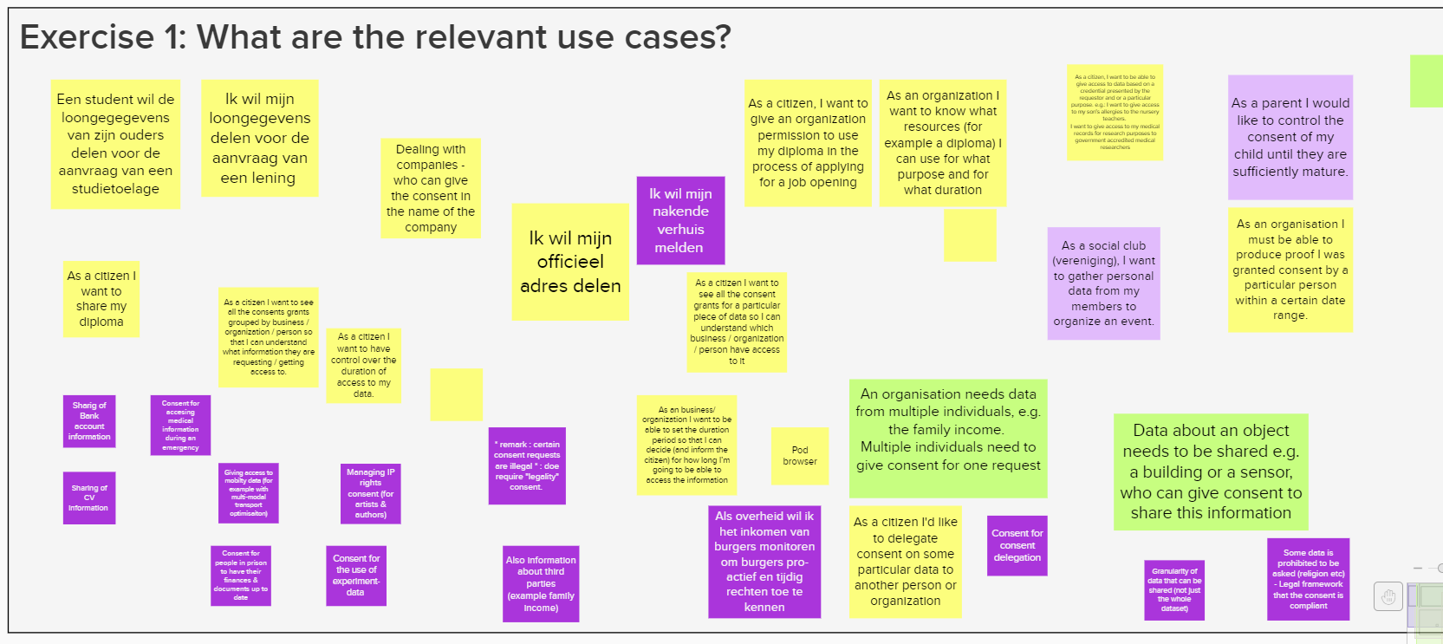

Sharing of different domains/categories of data. E.g.,:

* Wage slips
* Bank account details
* Address
* Diploma’s…

It’s important to mention that multiple parties can be involved in a consent, while only one person (the requester) needs to give the consent.

* For example, a whole family can be involved. One person can give consent for the group. E.g., someone needs to share the income of the whole family to get a loan.
* Joined/shared consent, not delegation of consent.
* Some important questions around this scenario: for example, what if someone revokes from the family?
* Same for a company: who can give consent in the name of a company?
* GDPR cases are all about individual data and not a group of people you are involved in.
* Data model needs to allow multiple persons to be involved in the process.

Give people the possibility to manage their consents:

* Being able to see ‘your list of consent’ in which you should have an overview and be able to change consents.
* One central place where you can manage this.
* PodBrowser is an interface that works like this. Inrupt is working on this using the Data Privacy Vocabulary (DPV) model.

Consent management might also mean that for certain demands it needs to pass through a legal framework to check if the request is not illegal.

* Legislation at this point to look at is GDPR within the EU.
* Existing models only give access to data or not, simple yes or no. But no validation as to whether the sharing of the data is legal or not.
* It’s important to define which attributes are needed for the given purpose. The full dataset as a whole is too broad.
* Does this issue need a legal or technical approach?
* Who will enforce the GDPR legislation? No authority that does this at this moment. This could be a role to be looked at.

**Exercise 2: High level data (concepts) needed to support the use cases**

A picture of the outcome of the brainstorming session is shown below:

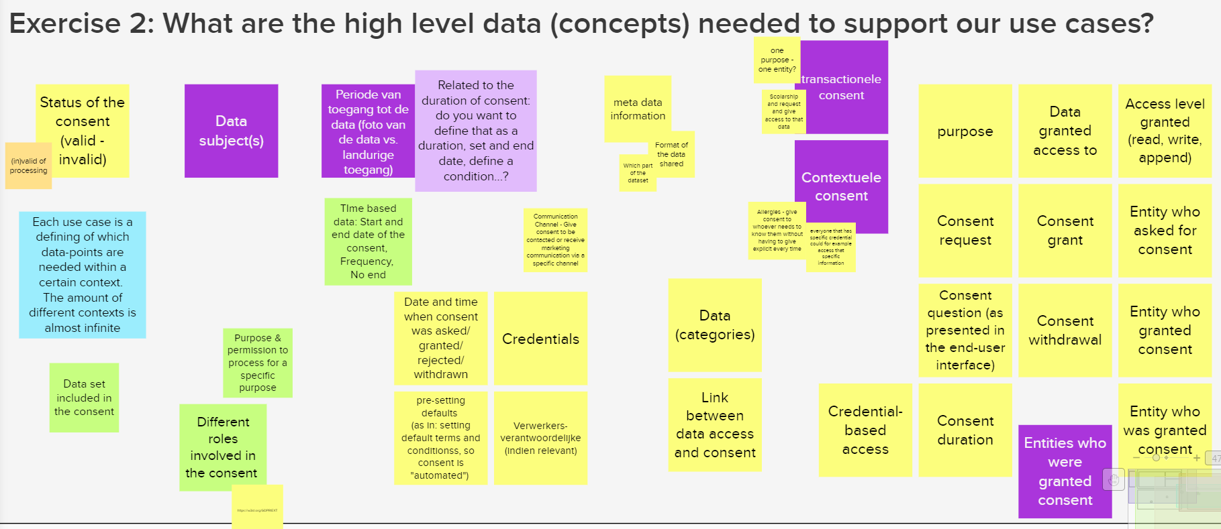

‘Consent’ is broader than ‘data access’: For consent you need to look at period, purpose, receivers… and give them access to the data. So, the link between data access and consent needs to be looked at carefully and it is important to understand the difference.

Consent should always be linked to a purpose. For example, a bank can only look at financial data for the specific purpose on which you gave them consent. Difference between giving consent to have access to live data for a certain period versus giving consent to have access to a snapshot of data for a period of time.

Transactional versus contextual consent:

* Transactional: Sharing specific data needed to complete a certain transaction. More a snapshot of data. This is a very clear context.
* Contextual: A given context in which you want everyone needing the data to have access to it.
  + Give consent for different purposes within a context. Contextual consent is less clear, so it is important to determine boundaries so that not everyone can access the data and that the person who shares it clearly knows what they are sharing.
  + Long term use of the consent for multiple purposes and entities.
  + Capability based access: linked to contextual consent. Everyone having a specific credential can access the data. E.g., everyone who is a nurse can see my allergies.

Different roles involved in consent. Important to define and label these.

Consent is like a contract. High-level data will not be enough to get there, but on the other side we want to become something like cookies, which no one reads. It will be difficult to educate everyone on the details.

Format of the shared data should also be looked at. Would be good if it is linked to the consent, but it could be too exhaustive to include the data format. In this case we differentiate between the consent related data and the actual data within the consent which also will have to be defined. Need to be an agreement of the format in which specific data will be shared.

You need to be able to define, fine grained, to which part of a dataset you give access. A consent request could be broader than what the subject wants to share. Difficult to tackle, but important.

Status of the consent; validity of the consent. Attached to the status are some very well-defined rules (out of time, legal issue…), cfr. GConsent standard.

Should the communication channel be part of this discussion? Use case: give consent to receive marketing information by phone and not by mail.

**Exercise 3: Relevant data standards**

A picture of the outcome of the brainstorming session is shown below:

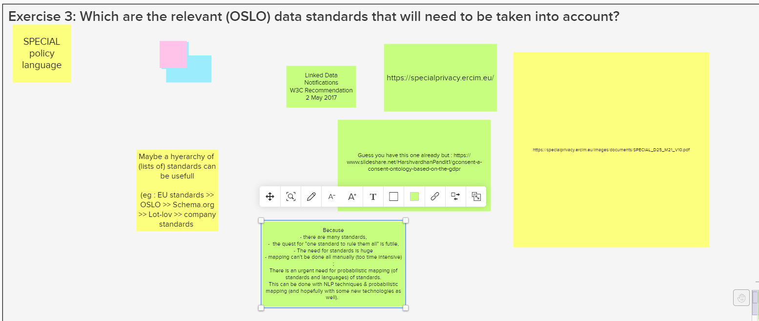

* SPECIAL policy language: <https://specialprivacy.ercim.eu/images/documents/SPECIAL_D25_M21_V10.pdf>
* Linked Data Notifications - W3C Recommendation, 2 May 2017

Proposal for hierarchy in the list of standards: e.g., EU standards >> Schema.org >> Lot-lov >> Company standards

## Part 6: Q&A and next steps

Q: How will this project interact with the big projects like My Citizen Profile, Data Intelligence Hub and Customer ID Wallet?  
A: Focus of TRAPEZE is use cases of *digitaal vlaanderen*, other 2 use cases differ too much from this one. The output of this exercise could be useful for the other 2 (Deutsche Telekom & Deutsche Bank) but this is not a requirement.

The use case of diploma’s is good, but very simple. At some point more complex questions, cases, situations will arise and will have to be looked at. Can be useful to look at more complex use cases in a later stage of the project to cover these situations.

To close the workshop, an overview was given of the next steps in the coming months:

* Process the input from the brainstorm exercise
* Circulate the main findings of this workshop
* Further research and prepare the first thematic workshop
* Capture further input through GitHub